BS6202 Assignment 2
Yaoding Chen

Introduction
Lymphoblastoid cell lines (LCLs) is a major resource of genomic studies due to its ability to regenerate DNA from biological samples (Scheinfeldt et al., 2018). Recently, Oliva et al. (2020) recently reveal that there is a ubiquitous sex effects on gene expression. Yet, it is still interesting whether we can predict the sex according to differential gene expression pattern exhibited in our samples. This study aims to cluster the samples using a machine learning approach into to capture gender-specific patterns and make prediction of the sample’s sex based on gene expression pattern that is captured by our clustering.

Factor analysis
By importing the data and extracting data summaries, we learn that there the column names are 8792 genes’ names and there are 207 samples measured in total. We obtain different gene expression profiles (GEPs) of 209 LCLs, which were collected from 3 ethnicity groups during 2002-2006. Each profile covers 8792 genes in each sample. Normalisation of gene expression levels, which ensures accurate comparison between samples, and unsupervised clustering analysis, which allows us to evaluate heterogeneity or homogeneity of the data, are essential quality control steps in differential gene expression analysis. Here we use a R package called DESeq2 to perform the preprocesses. I transform the data with variance stabilizing transformation (VST) instead of the commonly used rlog transformation, as it is much faster for >50 samples.
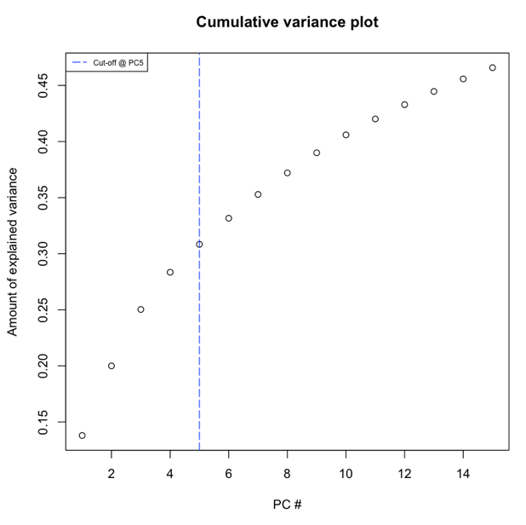
As each gene shows a different expression level in the dataset, dimensionality reduction is required to capture most meaningful features for sample clustering. There are two main advantages of doing so: first, dimension reduction will reduce the noise that could affect prediction accuracy; second, a lean, clean dataset can simplify and thus speed up calculation. Therefore, we perform a principal component analysis (PCA) with R. However, the below scree plot shows that the first 5 PCs with eigenvalue > 1 explains almost 80% of the variance (see the figure on the right), which means that we can reduce the dimensionality from over 200 to only 5, while losing only 20% variance.
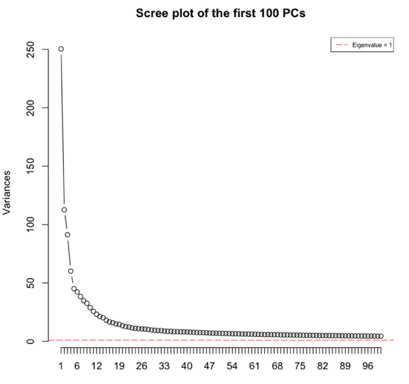

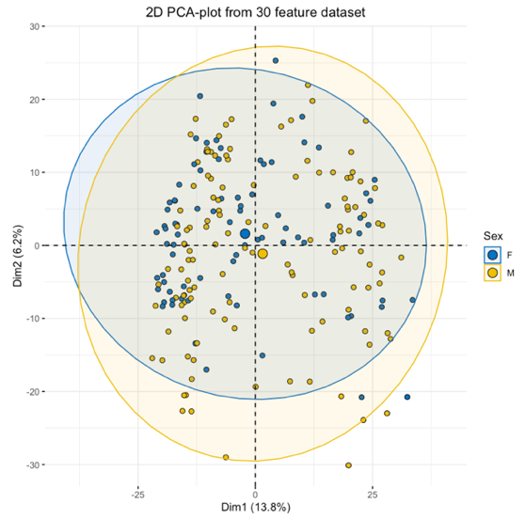
We can then visualise date (by year), ethnicity (by region) in different colours. And it is interesting to notice that there might be interaction between factors (i.e., date and ethnicity), which is not as expected. Note that such distinct patterns of date and ethnicity groups may cause Simpson’s paradox in some scenarios, so this might not be the satisfying PCA results we want. However, there is no clear sexual pattern for the data (see the figure on the right), which means sex might not affect our data too much. However, this would be a bit problematic when we are to do the next step, i.e., to make a supervised model according to sex.
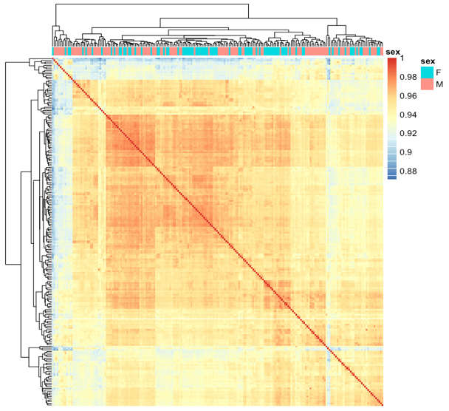

Task 1: Sample Clustering
First of all, hierarchical clustering is a powerful technique that allows you to build tree structures from data similarities. You can now see how different sub-clusters relate to each other, and how far apart data points are. For many other clustering techniques, we may need to identify the number of clusters which is not typically required in hierarchical clustering. Also, the R package DEseq2 makes such clustering such clustering quite easy. Also, according to the results of hierarchical clustering, it is possible to find different larger clusters which can be later used for classification.
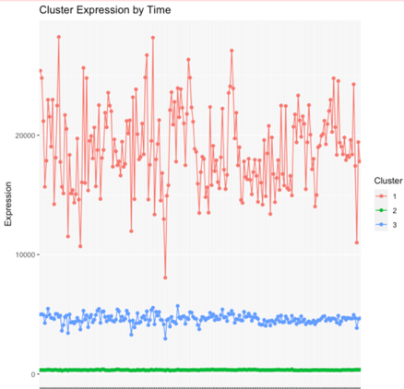
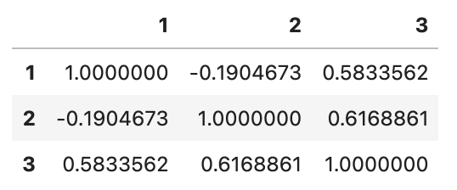
However, as shown in the heatmap, the clustering is not well corresponded to sex, which provides little indication of sex. Thus, such clustering might not be helpful to sex classification. Also, it is evaluations for hierarchical clustering is quite different from that of other clustering techniques, and I probably will continue with other techniques, such as k-means. This requires a priori knowledge about the optimum number of partitions (clusters), thus the classic question ‘How do i determine the correct number of clusters?’

As PCA results indicates, the data is mainly impacted by 5 PCs. According to the heatmap, there could be 3 clusters at least, which will be considered the k in our clustering. As is shown in the correlation matrix, the 3 clusters are quite dissimilar to each other. Specifically, between SS/total SS = 82.8%, which indicates most of the data can be explained by the clustering.

Task 2: Sex Classification
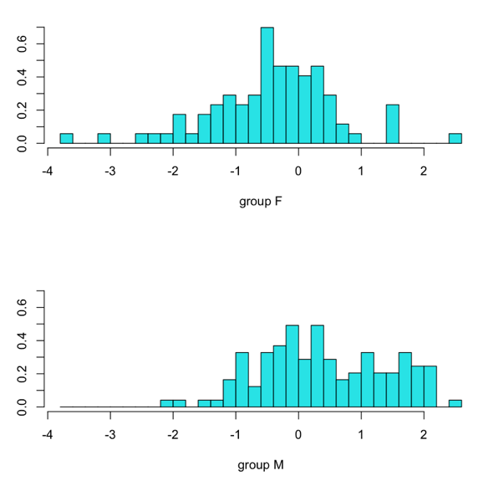
Here we want to make a prediction based on gene expression profiles. As we already know that there might be some 3-5 clusters that best describes our data and our prediction can be tested with our data. So this will be a supervised learning. There are some methods can be used for such predictions. Here we use LDA. Different from PCA, LDA can maximise the component axes for class-separation, which makes better clustering. The figure on the right shows the result of our LDA models. The complete results are shown as follows:
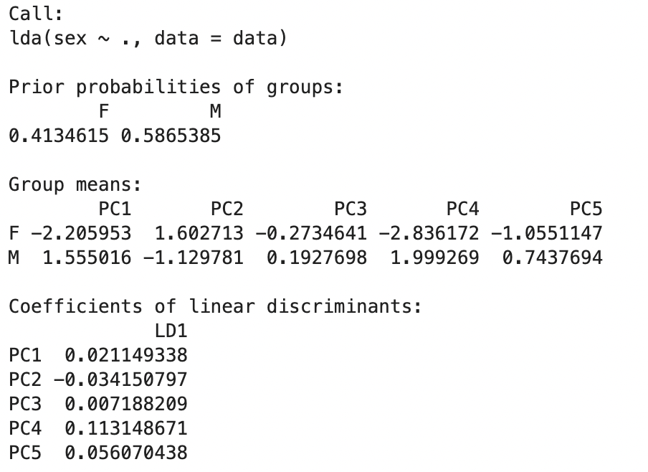
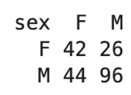
Besides, for all data modelled, our model reports a prediction accuracy of 33.65%, as is detailed in the table on the right, where there are a huge proportion of mismatched sex based on our prediction. This means the predictive model itself does not have a good performance.
The poor performance is not surprising as when we analyse PCA results, we have already find that sex does not have an impact on any PC. Also, in the above-mentioned plot of PDA, there is not any significant distance between the two clusters, which also indicates poor clustering. Thus, other feature selection methods, such as binominal bimodality index (BI) (Källberg et al., 2021), should be considered. Also, if a priori knowledge is allowed, we may use the gene list identified by Zhang et al. (2007) to simplify the features required. Besides, nonlinear approaches to classification could be considered, such as. Nearest centroid; for nonlinear ones, it includes k nearest neighbours (kNN), Artificial neural network (ANN), Support vector machine (SVM).

References
Källberg, D., Vidman, L., & Rydén, P. (2021). Comparison of Methods for Feature Selection in Clustering of High-Dimensional RNA-Sequencing Data to Identify Cancer Subtypes . In Frontiers in Genetics (Vol. 12, p. 217). https://www.frontiersin.org/article/10.3389/fgene.2021.632620
Oliva, M., Muñoz-Aguirre, M., Kim-Hellmuth, S., Wucher, V., Gewirtz, A. D. H., Cotter, D. J., Parsana, P., Kasela, S., Balliu, B., Viñuela, A., Castel, S. E., Mohammadi, P., Aguet, F., Zou, Y., Khramtsova, E. A., Skol, A. D., Garrido-Martín, D., Reverter, F., Brown, A., … Stranger, B. E. (2020). The impact of sex on gene expression across human tissues. Science, 369(6509), eaba3066. https://doi.org/10.1126/science.aba3066
Scheinfeldt, L. B., Hodges, K., Pevsner, J., Berlin, D., Turan, N., & Gerry, N. P. (2018). Genetic and genomic stability across lymphoblastoid cell line expansions. BMC Research Notes 2018 11:1, 11(1), 1–5. https://doi.org/10.1186/S13104-018-3664-3
Zhang, W., Bleibel, W. K., Roe, C. A., Cox, N. J., & Eileen Dolan, M. (2007). Gender-specific differences in expression in human lymphoblastoid cell lines. Pharmacogenetics and Genomics, 17(6), 447–450. https://doi.org/10.1097/FPC.0b013e3280121ffe

